
Computer Networks Lab_241L
UW-24-CS-BS-101
Registration NO:
Muhammad Talha_CS.3ndB
Lab Task # 06
UNIVERSITY OF WAH(UOW)

DEPARTMENT OF COMPUTER
SCIENCE

COURSE:

SUBMITTED TO:

Mr. Hassan Shafaqat
SUBMITTED BY:

TASK
Adding Router to Screen

Adding Switches to screen
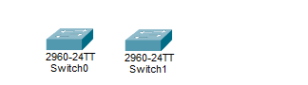
Adding Computer
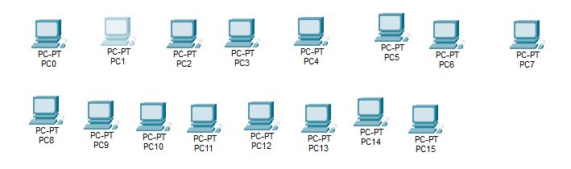
Arranging in order everything
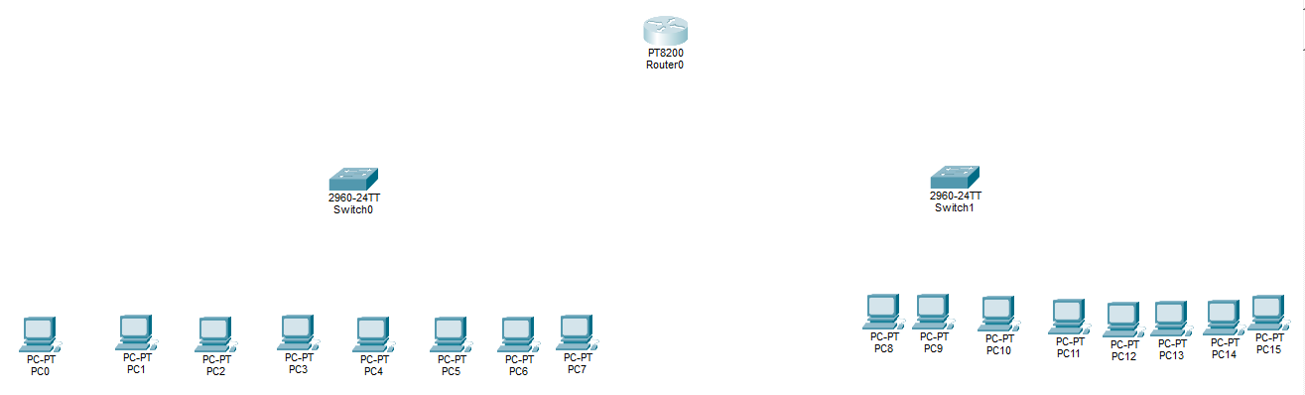
Attaching wires from pcs to switches
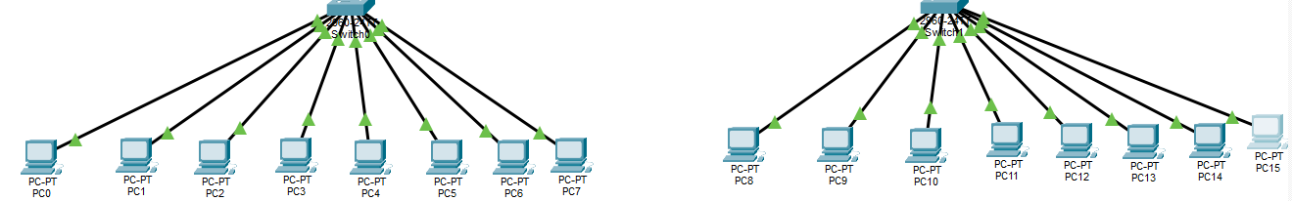
Attaching wires to Switches to Router
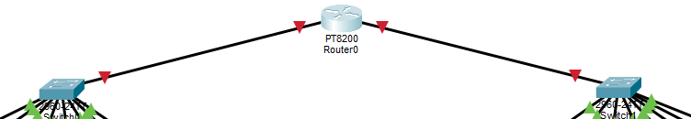

Assigning IP address to PC’s
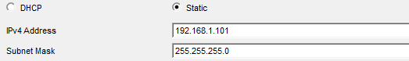
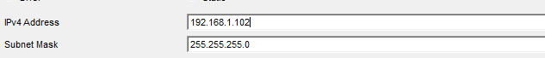
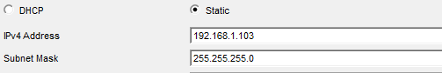
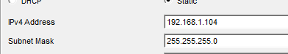
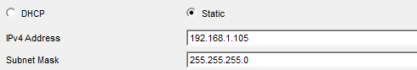
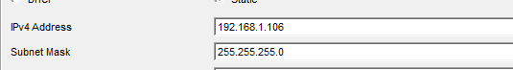
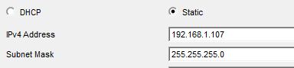
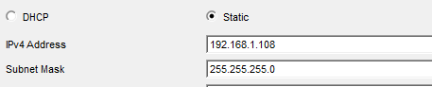
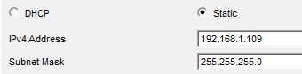
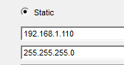
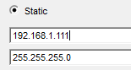
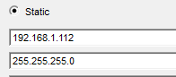
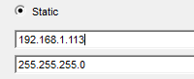
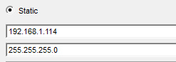
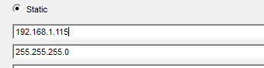
Sending Messages from ping
- From PC1 to All
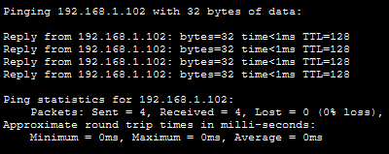
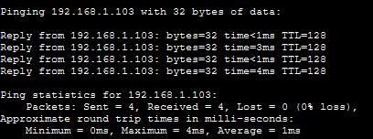
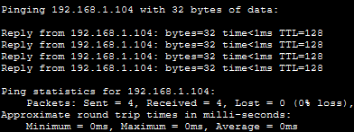
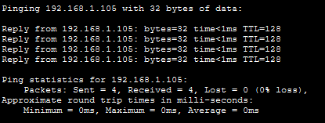
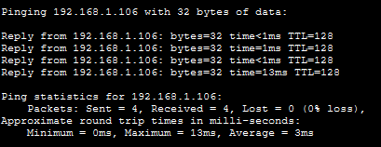
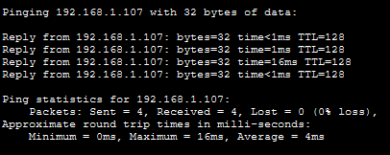
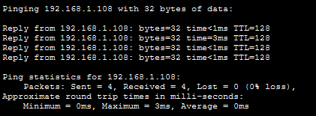

- From PC2 to All








- From PC3 to ALL







- From PC4 to ALL







From PC5 to All







From PC6 to ALL







From PC7 to ALL







From PC8 to ALL







From PC9 to All







From PC10 to ALL







From PC11 to ALL








From PC12 to ALL







From PC15 to All







From PC16 to ALL








